St. John’s House, Bury
Travel Plan

February 2023

Travel plan aims and objectives

Aim of St John’s House travel plan
The travel choices we make can have a negative impact on the local communities we all serve. Amongst other issues, traffic congestion can create air quality problems for many communities.
The primary aim of this travel plan is to:
“Reduce the number of single occupancy cars arriving at the St John’s House, by highlighting the use of more sustainable alternatives.”
The plan aims to positively influence the travel patterns and behaviours of St John’s House employees and visitors, to reduce reliance on the use of private cars through the encouragement of greater use of public transport and other sustainable modes of travel.
St John’s House travel plan objectives
The primary objectives are to:
- Increase travel awareness and promote sustainable travel behaviour, thus supporting the reduction of traffic congestion and improving air quality.

- Reduce travel costs for employer and employees.

- Reduce your carbon footprint.

- Encourage potential health benefits for employees through the encouragement of walking and cycling to the workplace and/or on business trips.

- Ensure that all staff and visitors are made aware of the travel plan.
Travel options to St John’s House

Introduction
There are many different ways to get to St John’s House. Being located in the centre of Bury means that there are good walking, cycling, and public transport options available to get here instead of travelling by private car. This section gives details of the different travel options available to get to St John’s House. This will be reviewed and updated as required every six months.
Walking and cycling
Walking and cycling are healthy and cheap modes of sustainable transport. Significant investment has been made to improve cycling links to Bury, which means St John’s House is well connected by walking and cycle routes. The map below shows two parameters; the inner one for a 15-minute walking distance and the outer one for a 15-minute cycling distance. The dark green lines show current and planned cycle routes being implemented.
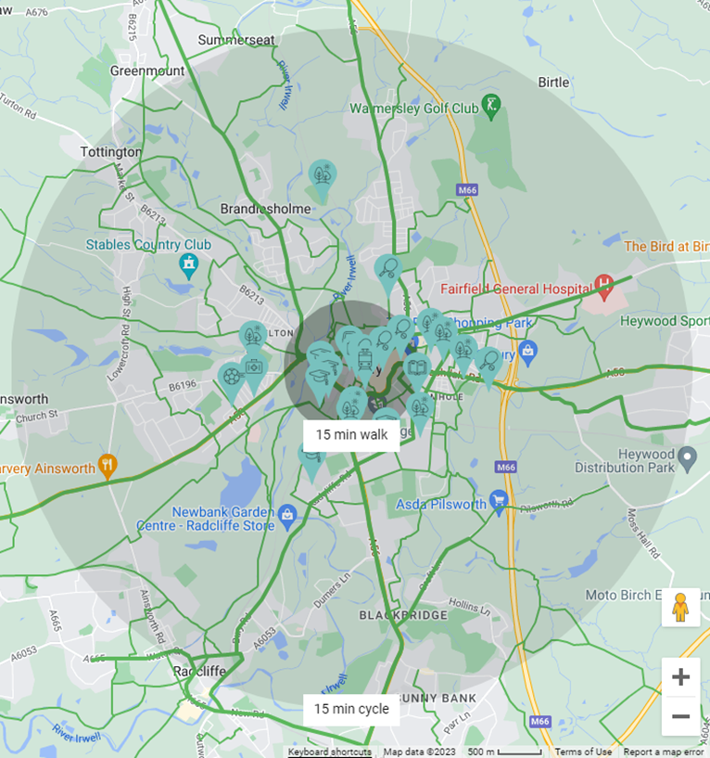

Walking
Bury Town Centre provides good pedestrianised access. To the north of the town centre, there is a well-lit underpass across Peel Way connecting Woodfields Retail Park and the residential area beyond. The junction of the Rock and Peel Way also has fully signalised pedestrian crossing facilities.
To the south of the town centre, there is a well-lit underpass across Angouleme Way connecting the town centre to the retail park and residential areas south of the A58. There is also a signalised pedestrian crossing on Rochdale Road, providing a link to the pedestrianised Rock Shopping area which links to St John’s House.
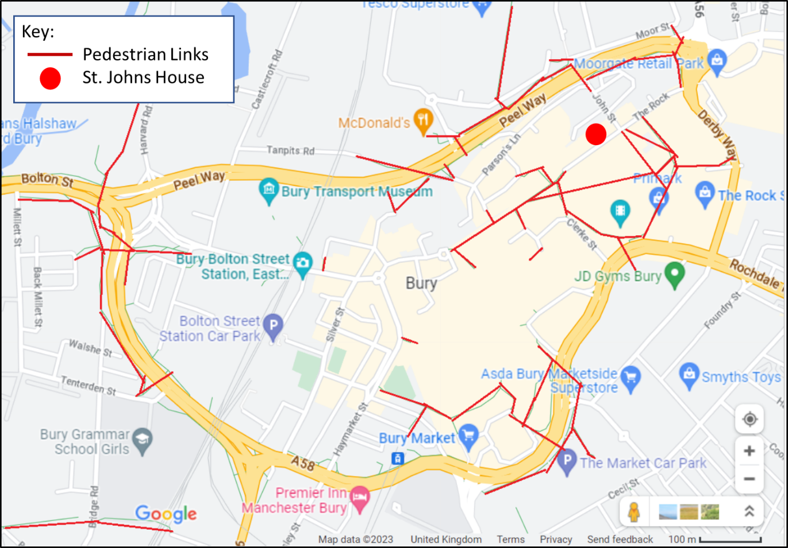
Cycling
Bury is well connected by a number of dedicated on and off-road cycle routes, allowing for easy access for cyclists of all abilities. To plan an appropriate cycle route to get to St John’s House, Cycling UK has developed a detailed journey planning tool available at: https://www.cyclinguk.org/journey-planner
The diocese offers staff reimbursement for cycling for business purposes. There is also a ‘cycle to work’ scheme available to staff, enabling them to buy a bike through salary sacrifice. This provides good financial savings as well as the ability to spread the cost over a year.
Opposite St John’s House are a number of cycle parking stands. These are in good view of St John’s House. At Bury Interchange a dedicated secure cycle hub facility is also available.

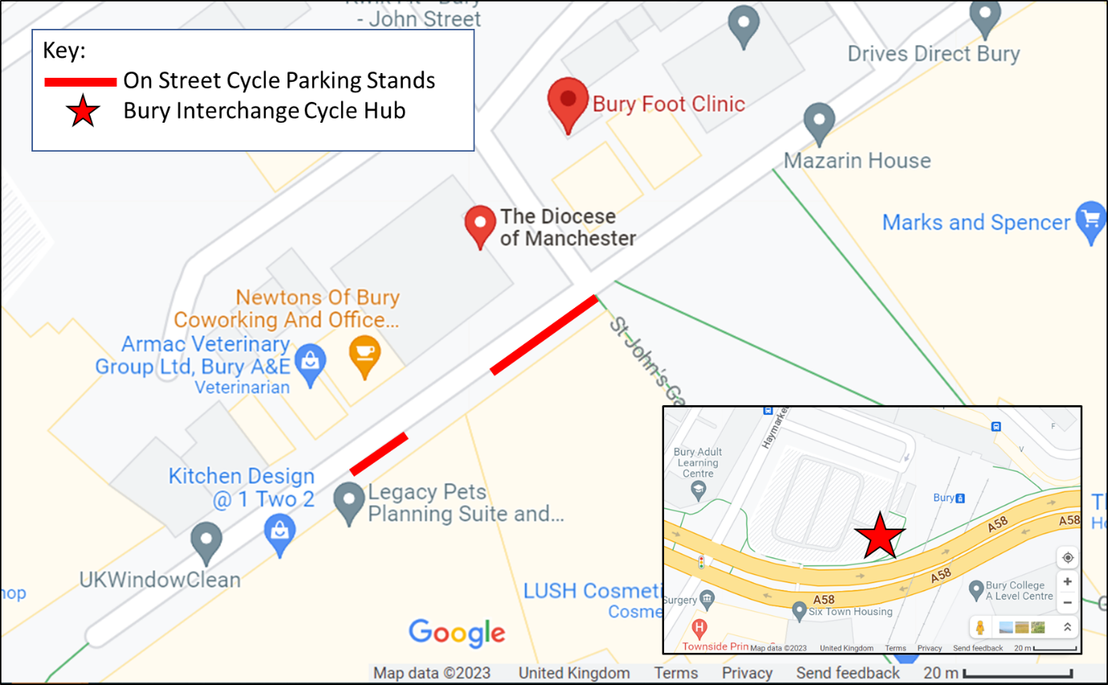
Bus Travel
Bury Town Centre is well-connected by bus. Recently, a flat single adult fare of £2 and all-day unlimited travel for £5 across Greater Manchester has been introduced. Even cheaper weekly, monthly and annual tickets are available too, meaning bus travel is a very cost-effective mode of travel.
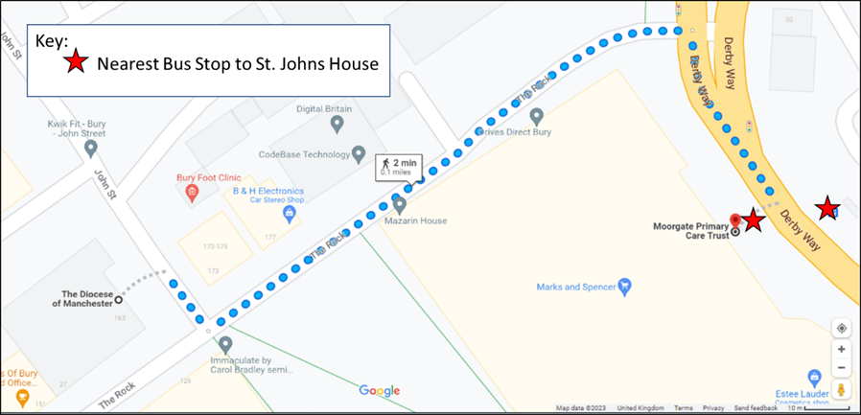
The nearest bus stop to St John’s House is next to Moorgate, just a couple of minutes’ walk away.

Services running from this stop:
467 – Rochdale via Fairfield & Bamford (every 30 mins)
468 – Rochdale via Fairfield & Bamford (every 30 mins)
472 – Ramsbottom via Walmersley & Rawtenstall (every 20 mins)
481 – Blackburn via Walmersley & Rawtenstall (every 30 mins)
483 – Burnley via Walmersley & Rawtenstall (every 30 mins)
B2 – Chesham – Limefield – Nangreaves (hourly)
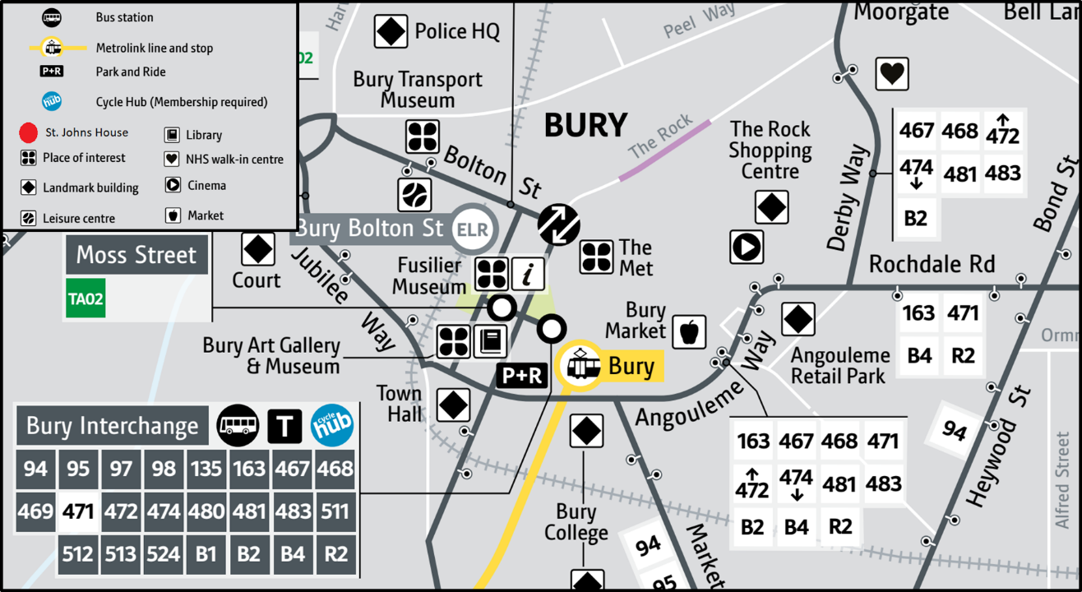
Bury Interchange has services which connect to Greater Manchester and beyond. The map below shows the services operating from stops across Bury Town Centre and the Interchange.

The full version of this map is available at:
https://assets.ctfassets.net/nv7y93idf4jq/1tauDTT32fm7M44o5yy3Y3/6495944efa4387ba870498014800c574/Bury_map.pdf
Further information on specific services and a bus journey planning tool is available at: https://tfgm.com/plan-a-journey

Metrolink (Tram)
Bury was one of the first towns in Greater Manchester to be connected to the Metrolink tram system. This provides a good direct link to Manchester City Centre and beyond. The nearest Metrolink Stop to St John’s House is a 7-10-minute walk through the pedestrianised town centre. Tram services run from 5:48am to 23:24pm with a six-minute frequency.
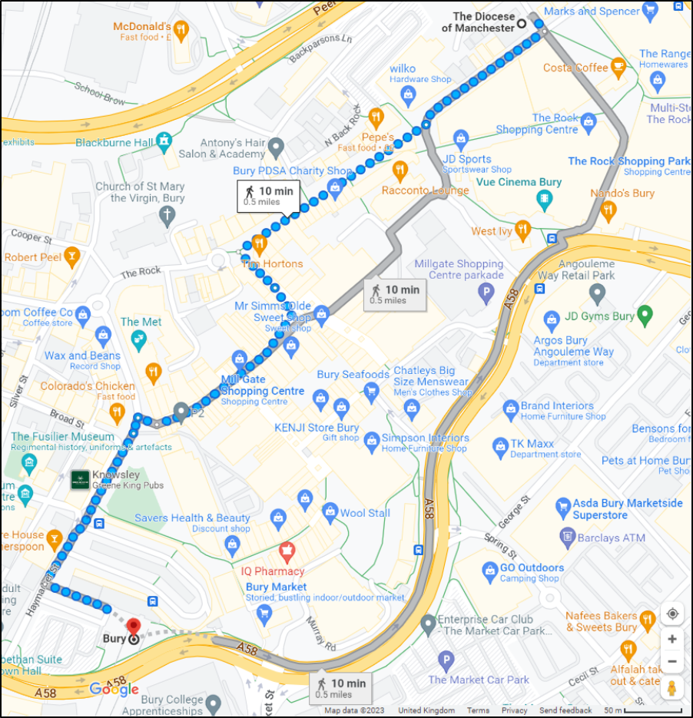
Park and Ride is a popular option for Metrolink passengers. Many Metrolink Stations have free car and cycle parking available for Metrolink users. Whitefield, Prestwich and Radcliffe in particular have significant Park and Ride facilities. The Metrolink network is presented on the following page.

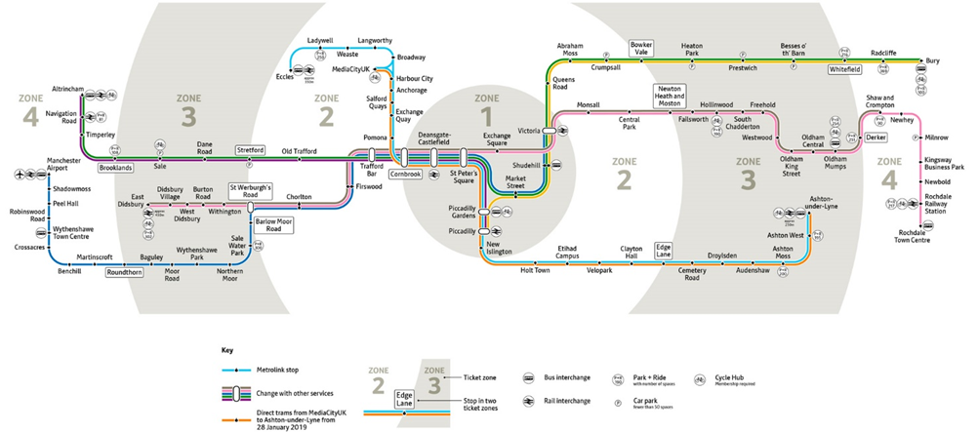

TfGM and the local councils are developing significant improvement plans for sustainable travel across Greater Manchester, with the Bee Network. This includes the development of Quality Bus Corridors connecting Bury to Bolton, and Bury to Rochdale. There are also improvements planned for Metrolink stations connecting to Bury, including increased travel options to and from stops, and improved cycle access provisions. The travel plan will be updated to reflect these when they are delivered.
Rail Travel
The nearest mainline stations for St John’s House are Manchester Victoria and Manchester Piccadilly. Both have Metrolink services running from them which connect to Bury.
Information on train services and station facilities is available at: www.nationalrail.co.uk
Taxi
There are several Private Hire Taxi operators within Bury. These include:
- Harvey’s Cars - 0161 764 6894

- Magnum Whiteline – 0161 766 6666

- Royal Peel Cars – 0161 705 2000

- Uber – Uber.com or via the app

Car Sharing
Where travel by car is required to get to St John’s House, car sharing can provide significant benefits both financially and environmentally. Colleagues and visitors who travel the same route already have the opportunity to car share. Liftshare is a national organisation which provides an opportunity for people who are travelling the same routes to connect with each other. It is free and easy to use: https://liftshare.com/uk
Car Parking
St John’s House does not have parking provisions for visitors. However, there is ample parking within easy reach of St John’s House, details of which are given below.
Disabled Parking
There are seven on-street Blue Badge holders' disabled parking spaces in very close vicinity to St John’s House, as shown on the map below. A valid blue badge must be displayed when parked in one of these bays. Parking here is free and there is no time limit for users with a valid, displayed Blue Badge. It must be noted these are very popular for users and no guarantee of their availability can be made. When parking in a standard pay and display bay on the street, you must purchase a ticket whether or not you have a Blue Badge. There are also two disabled parking spaces in the small car park to the rear of St John’s House, which can be booked in advance by contacting reception on 0161 828 1400.
Additionally, there are disabled parking bays in the local off-street car parks (please see sections below for details). A Blue Badge must be displayed when parking in dedicated spaces for disabled users in off-street car parks. Parking charges will also apply to parking here.
For more information on disabled parking within Bury Town Centre please visit: https://www.bury.gov.uk/index.aspx?articleid=11770
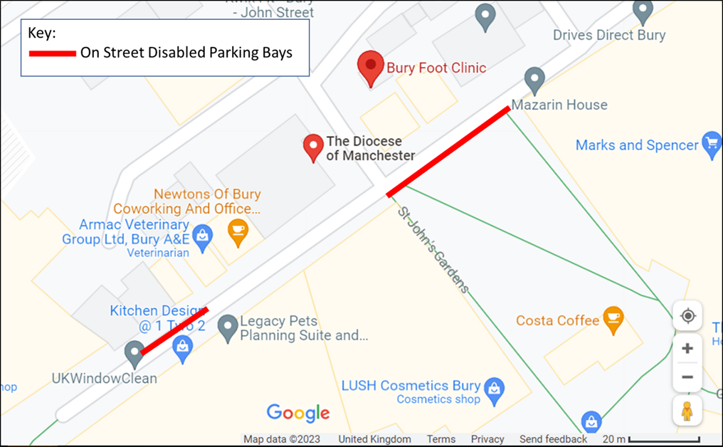
On-Street Car Parking
On-street pay and display parking is located around Bury Town Centre and near to St John’s House on Parsons Street (although it must be noted there is closer off-street parking available). Payment is made by pay and display or ring and go (mobile payment). These bays are often time-limited with no return periods. Please therefore consider the duration of your stay when using these.
Off Street Car Parking
There are a number of off-street car parks within short distance of St John’s House. The nearest public car park to St John’s House is the Paradise Mill Pay and Display Car Park, which offers all-day parking for £4.90. If staff require season parking please speak to reception to secure season parking discounts at the Rock Car Park. The map below shows all the off-street parking provisions in Bury Town Centre. For information on charging and stay lengths please visit: https://www.bury.gov.uk/index.aspx?articleid=11204
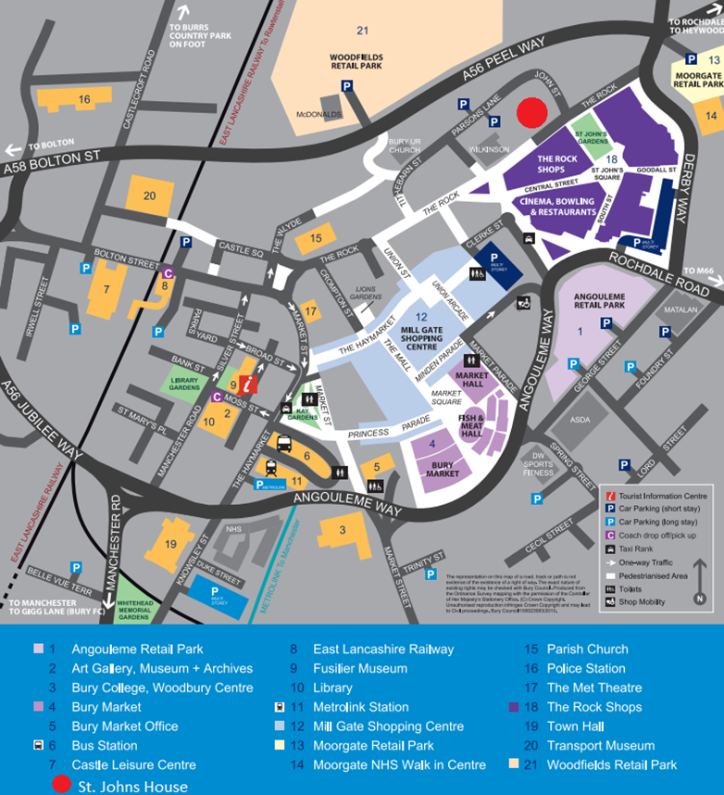
Electric Vehicle Charging
By 2030 the sale of new petrol and diesel cars will be banned in the UK. As more people switch to electric vehicles, more public charging will be needed. There are not any dedicated EV charging points at St John’s House. However, near to St John’s House there are several public EV charging points available, including at Parsons Lane Car Park, Moorgate Retail Park Car Park and Millgate Shopping Centre Car Park. Further details of public charging points are available at: www.zap-map.com
Air Travel
The nearest airport to St John’s House is Manchester Airport. There are direct trains to Manchester Victoria, where connecting trams to Bury are available via the Metrolink Network. Private Hire taxis are also available from the airport.

