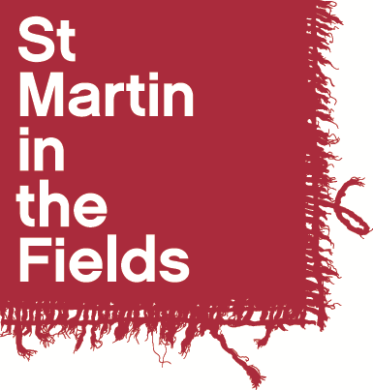

Diocese of Manchester Associate Choral Leader Programme 2024-25

Application Form

Name: ……………………………………………………………………

Please indicate which position you are applying for (you may apply for more than one):

Associate Choral Leader (Diocese of Manchester: Choral Scholars)
Associate Choral Leader (Diocese of Manchester: Community Choirs)
Associate Choral Leader (Diocese of Manchester: Childrens Choirs)

- Personal Details

First Name(s): | Contact Telephone Number(s):
Surname: | Email:
Contact Address:

- References

If you are shortlisted for an audition, we may wish to take up references. You should give the name of one musical referee and one other referee who can give us a character reference.

First Referee
Name:
Position:
Relationship to you:
Address:

Telephone Number:
Email address:
May we contact this referee prior to interview? Yes No

Second Referee
Name:
Position:
Relationship to you:
Address:

Telephone Number:
Email address:
May we contact this referee prior to interview? Yes No

- Education

Schools, Colleges, Universities or Institutes of Further Education attended (including part time) | Dates |  | Qualifications gained
 | From | To

- Please answer the following questions

Your answers will provide the basis for some discussion in the interview.
- Why are you applying for the Associate Choral Leadership programme?
- Tell us about your experience in choral conducting and/or vocal leading, and comment in particular on any experience you have in leading children’s choir’s (if you are applying for Dunstable Priory), and adult community choirs (if you are applying for Square Mile Churches/Diocese of Manchester)
- What else do you plan to be doing alongside the Associate Choral Leadership and how do you see this arrangement working in terms of compatibility and time management?

- Declaration

I certify that the information I have provided on this application form is correct and agree that the information given can be used as a basis for some discussion in the choral leadership interview.

Signed: ………………………………………………………………….. Date: ………………………………

- To apply

Please return the application form, along with a current CV, by email to Phoebe Palmer, Music Administrator at phoebe.palmer@smitf.org by Monday 24th June at 5pm at the latest.

Shortlisted applicants will be asked to direct a short choral rehearsal, and undertake an interview. Auditions will take place on Friday 5th July, Saturday 6th July (Manchester) and Sunday 7th July (London).

