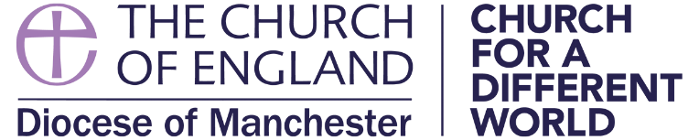

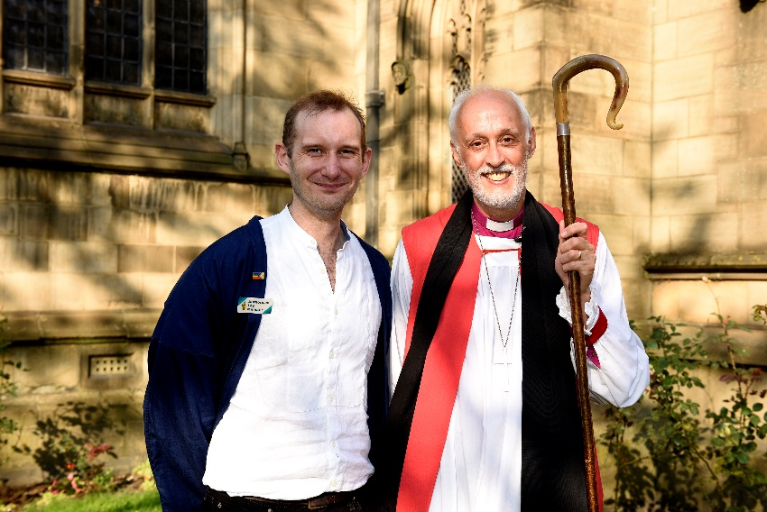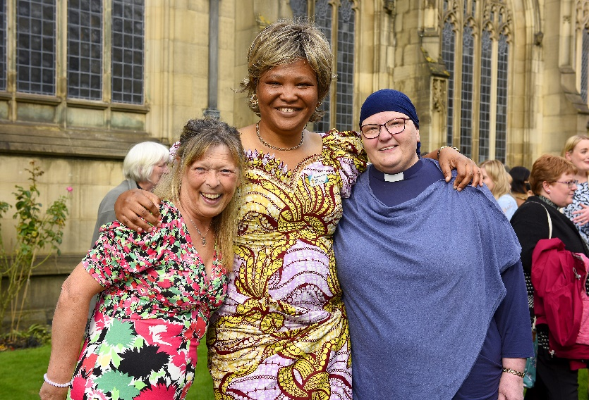

**Authorised Lay Ministry**

**2025**

**What is an Authorised Lay Minister?**

Authorised Lay Ministers (ALMs) are lay people, active in church life, who have been identified by their parish as having a particular gifting, vocation and calling to lay leadership, i.e. those called to work collaboratively alongside their incumbent and wider ministry teams with a distinct focus on growing, nurturing and serving their local parish community. ALMs also play a key role in resourcing, equipping and encouraging all God’s people to carry out the vision and mission of their local Mission Action Plan (MAP).

ALMs are nominated by their incumbent and PCC for training in line with the diocesan selection criteria and once trained receive authorisation from the Bishop of Manchester to carry out a mutually agreed ministry role back within their local parish context. An ALM’s authorisation lasts for 3 years after which time it can be reviewed, updated and renewed.

What does the training involve?

The ALM training course is broken down in to three parts that run each year from January to September.

**Part 1: Induction and core module**

Between January and Easter, candidates are inducted and then undertake an eight-session Core Leadership Module.

**Part 2: Ministry elective and Summer conference**

From Easter to June, candidates will complete their chosen ministry elective course. There are currently nine courses available. The term then ends with the annual ALM Summer Conference.

**Part 3: Ministerial role description and authorisation**

From July, candidates will work alongside their incumbent and PCC to finalise their ALM Ministry Role Description before their service of authorisation and commissioning in September. There is also a pre-authorisation retreat day.

How can I be selected?

Authorised Lay Ministry is based on a collaborative model of ministry and is therefore not about any one person’s desire to serve or minister. Any nominations for ALM must meet the [diocesan selection criteria](https://d3hgrlq6yacptf.cloudfront.net/5fbd76bf103bd/content/pages/documents/alm-handbook-for-clergy-and-pccs_2022.pdf), align with the parish's MAP and represent the expressed desire of the wider parish community. The incumbent, individual and PCC must discern and respond to God’s call together.

How much does the course cost?

All the costs of ALM training are met by the diocese but parishes are expected to support their candidates if help is required with basic costs such as travel expenses. However, if finances are a barrier to participation, please get in touch for further advice and support.

Is ALM the only way to access lay ministry training?

All of the ministry elective training courses offered on the ALM programme are also open as stand-alone courses to any lay people wanting to develop their call and gifting to Christian ministry and service. For more information on this please see our website page ‘General Lay Courses’.

* Parish Admin, Finance and Governance
* Pastoral Outreach and Listening
* Prayer and Spirituality
* Worship and Liturgy
* Community Outreach
* Mission and Evangelism
* Ecology and Creation
* Youth Work
* Children & Families

**Ministry Elective Courses**

More information

For further information about the course and details on how to apply please see:

[**www.manchester.anglican.org/lay-ministries/ALM**](http://www.manchester.anglican.org/lay-ministries/ALM/)

 or you can contact, **Jamie Mackenzie (Local Ministry Officer)**

[jamiemackenzie@manchester.anglican.org](mailto:jamiemackenzie@manchester.anglican.org)

Next course

**Starts January 2025**

**Application deadline for new ALMs is**

**13 January 2025**