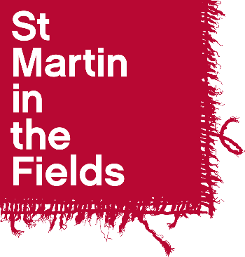

Diocese of Manchester

Choral Scholarship 2024-25

Application Form

Name: ……………………………………………………………………

Voice Part: …………………………….……….

1. Personal Details

First Name(s): | Contact Telephone Numbers:
Surname: | Email:
Contact Address:

2. References

If you are shortlisted for an audition we may wish to take up references. You should give the name of one musical referee who has experience of your singing and one other referee who can give us a character reference.

First Referee
Name:
Position:
Relationship to you:
Address:
Telephone Number:
Email address:
May we contact this referee prior to interview? Yes □ No □

Second Referee
Name:
Position:
Relationship to you:
Address:

Telephone Number:
Email address:
May we contact this referee prior to interview? Yes □ No □
3. Education

Schools, Colleges, Universities or Institutes of Further Education attended (including part time) | Dates |  | Qualifications gained
 | From | To

- Please answer the following questions

Your answers will provide the basis for some discussion in the interview.
1. Why are you applying for a Choral Scholarship with the Diocese of Manchester?
2. What do you plan to be doing alongside the scholarship (e.g. university / college course; gap year etc) and how do you see this arrangement working in terms of compatibility and time management?
3. How would the scholarship fit in with your plans for the future?

- Declaration

I certify that the information I have provided on this application form is correct and agree that the information given can be used as a basis for some discussion in the scholarship interview.

Signed: ………………………………………………………………….. Date: ………………………………

- Audition Dates

Please indicate your availability for audition on:
Tuesday 4th June 10am- 2pm (St Pauls, Withington)
Wednesday 5th June 2pm – 6pm (St Pauls, Withington)
Friday 7th June, 2.00 – 6.00pm (St Martin-in-the-Fields)

If you cannot make any of the times above, please let us know here and on your email. We will try to arrange an alternative time, or a zoom audition.

Please return this form, along with a current CV, by email to Phoebe Palmer, Music
Administrator at phoebe.palmer@smitf.org

The deadline for applications is 5pm on Friday, 28th May 2024.

