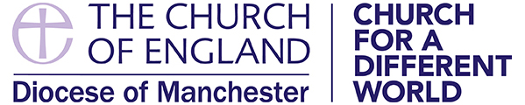
NOTES FOR APPLICANTS
Increasingly role descriptions and person specifications are being used in appointments. These help all parties to be clear about what qualities and experience are being sought and on what basis the decision to appoint will be made.

This form helps you to demonstrate your calling to the office, showing how your gifts, skills, experience and qualities match the criteria. It allows those making appointments to demonstrate their discernment of the successful candidate by assessing applicants against selection criteria in a structured way, avoiding bias. In completing the form, you should ask yourself “What might I under God be able to bring to the needs of this office?”

You are encouraged to complete the form electronically. This eases administration and allows interviewers to concentrate on the facts you are presenting rather than having first to read your handwriting. Start with the most recent one first when listing dates.

Please complete each section fully. Saying ‘see CV attached’, for example, is not sufficient. Once you have completed the form read it through and check you have shown how you meet each of the criteria.

Section 6 – Personal Statement allows you to explain why you are applying for the post and, using examples from your previous work and experience, why you are suited to it. Pull together the relevant information from other parts of the form. Don’t forget to include information about things you have done in your career before ministry or relevant interests. Concentrate on facts, things your interests have caused you to do, rather than mentioning a general interest in a particular subject. But don’t be too detailed, 2 pages of personal statement is enough. The interview gives the opportunity to explore these areas further.

If there is a particular requirement about a post holder e.g. a PCC has passed a Resolution under the House of Bishops’ Declaration on the Ministry of Bishops and Priests, and a woman is therefore not an acceptable appointee or someone remarried after divorce and with a former partner still living is not acceptable, the person specification needs to make this clear and if appropriate you need to address it in your personal statement.

Some requirements however are more general and will not be mentioned in the person specification. For example, the Ecclesiastical Offices (Age Limit) Measure 1975 does not allow the appointment of those over 70 unless in a fixed or limited term licensed appointment under regulation 29(1) (b). If you are in any doubt about your eligibility, you should ask those responsible for making the appointment before you complete your application.

Personal information is confined to the confidential part of the form. This means only the person administering the process, the bishop and those who need to see it will have access to it. It means those interviewing you are not influenced by factors that are not relevant in making the appointment.
The bishop may ask you questions about the confidential information at your private interview because he or she has to assure himself or herself that your lifestyle is commensurate with a) priestly ministry and b) the person specification for the post.

If you are appointed, you will be invited to provide information about you and your family so the bishop has the information he or she needs to provide you with pastoral care.

